Document Scanning Test
Module : Receiving Module
Function : Document Scanning

Testing Steps and Observations

Steps | Description/Observations
1 | Initiated document scanning for a chosen receipt in Receiving Entry's tool menu
2 | 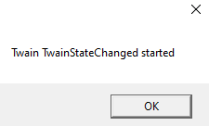  The popup message "Twain TwainStateChanged started" appeared twice. In both times, the “OK” button was clicked.
3 | 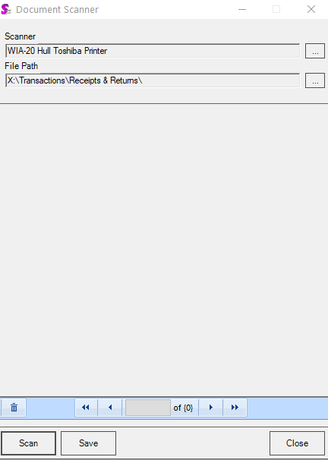  Clicked the “Scan” button to initiate the document scanning process when the Document Scanner screen opened.
4 | Clicked “Ok” button when the “About to acquire” popup messsage appears.  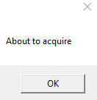
5 |   The popup message "Twain TwainStateChanged started" appeared twice again. In both times, the “OK” button was clicked.
6 | 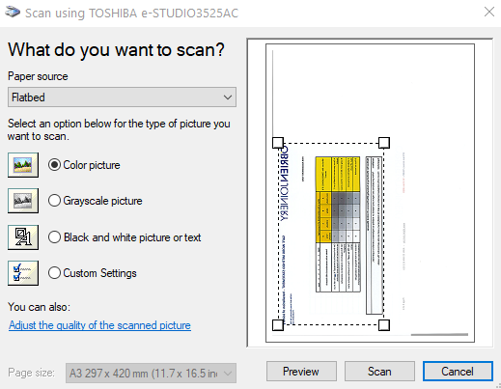  When the “Scan using TOSHIBA e-STUDIO3525AC “ screen appears, the “Preview” button was clicked to display the scanned document on screen.
7 |   Clicked the “Scan” button in the “Scan using TOSHIBA e-STUDIO3525AC “ screen and the “Twain TwainStateChanged started” message appeared twice again. In both times, the “OK” button was clicked.
8 | 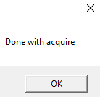  Clicked “OK” when the “Done with acquire” button appears
9 | 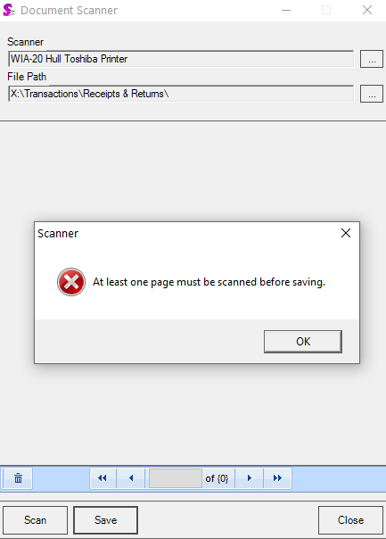  Clicked “Save” button in the Document Scanner Screen and the message below appears. (Error 91 did not appear)
10 |   Clicked the “Close” button in the “Document Scanner screen and the “Twain TwainStateChanged started” message appeared twice again. In both times, the “OK” button was clicked.
11 | An Unhandled Exception Error occurred. Details saved in attachment (Document Scanner Error Details.txt).  Clicked the “Continue” button to return to the Document Scanner screen.  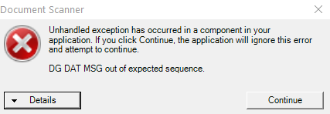
12 |   Clicked the “Close” button again in the “Document Scanner screen and the “Twain TwainStateChanged started” message appeared three times. In all cases, the “OK” button was clicked.
13 | The Document Scanner screen closed and returns to the Receiving Entry screen, however Seradex entered HANG state. Closed Seradex via Task Manager.

